KERALA GOVERNMENT POLYTECHNIC COLLEGE
WESTHILL, CALICUT-673005

DEPARTMENT OF COMPUTER ENGINEERING

IDEAL GURU- Online FEEDBACK SYSTEM
(REPORT OF APPLICATION DEVELOPMENT)
Fifth semester Computer Engineering (2016-17)

Submitted By

ARUN SANKAR.R.K ARUN UDAY.P
(REG NO.14130458) (REG NO.14130459)

KERALA GOVERNMENT POLYTECHNIC COLLEGE
WESTHILL, KOZHIKODE-5

CERTIFICATE
  - Certified that this is the Authentic Report of Mini Project done by ARUN SANKAR R.K (14130458) and ARUN UDAY.P (14130459) impartial fulfilment of the requirement for the award of Diploma in Computer Engineering under the Directorate of Technical Education, Government of Kerala at Govt.Polytechnic College, Westhill, Calicut during the year 2016-17.

  - Guided By Head of Department

  - Internal Examiner External Examiner

  - Place:
  - Date:

ACKNOWLEDGEMENT
I think the God, the almighty for blessing us in making our project a successful one. The satisfaction that accompanies the successful completion of any task would be incomplete without the mention of people whose ceaseless cooperation made it possible, whose constant guidance encouragement crown all efforts with success.
We here by wish to express our sincere gratitude to Mr. MUHAMMED AZEER.A.K Head of Department of Computer Science and Engineering and project guide Mrs. NISHAMOL.P.H and also other faculties Mr. JAWAHAR ALI, Ms. BABY MANJUSHA , Ms. ANU MANOHAR , Mr. SUDESH.K.M, Mrs. DEEGNA.M and Mr.SREENATH.M , for the guidance , inspiration and constructive suggestions that was helpful for us in the preparation of this project . We also thank our friends who helped in successful completion of the project.

ABSTRACT
Teaching skill evaluation of teachers in higher education is a serious challenge that faces by management. Several features and factors are considered leading professional growth of an organization to evaluate the performance, such as relationship with students, relationship with other faculties, teaching ways, etc.
However collecting data is a difficult task. Usually standard “form filling” method used by most of the institutions. It is really time consuming and head ache. We are going to implement a website which can collect feedbacks from students and staffs without providing their identity. By using a unique account.
In this project we are going to use PHP scripting and JAVA Scripting to create the webpage and SQL for backend. We hope it has been implemented in a teaching evaluation system to enhance then teaching skill also the character of good teachers through the evaluation.
CONTENTS

1. INTRODUCTION……………………………………….
2. SYSTEM ANALYSIS……………………………………
2.1. FEASIBILITY ANALYSIS
2.1.1. ECONOMICAL FEASIBILITY
2.1.2. TECHNICAL FEASIBILITY
2.1.3. BEHAVIORAL FEASIBILITY
2.2. EXISTING SYSTEM
2.3. PROPOSED SYSTEM
3. SYSTEM SPECIFICATION……………………………
4. SYSTEM DESIGN……………………………………….
4.1. DATABASE DESIGN
4.2. DATA FLOW DIAGRAM
4.3. FORM DESIGN
5. CONCLUSION…………………………………………….
6. FUTURE SCOPE …………………………………………

- INTRODUCTION

Our project is to create a website which gives the feedback of the faculties in our college. Since to evaluate a teacher is a tedious task, it makes it simple. It creates an opportunity for the teachers to receive feedback from students. There is a notification page for students in their concerned account which shows a reminder for students. That is recent assignments, projects, test papers can be viewed through this.
This website is not open for all, which means the students of the concerned department/institution will only be part of this. Each of them will have a unique password. There is a registration process to login the page first. Only the users can login to their account through their password. The name of the user will be hidden while sending the feedback. So it creates a platform, creating a good interaction without hesitation with the concerned faculty.

2. SYSTEM ANALYSIS

2.1. Feasibility Study

2.1.1. Economic Feasibility:
This procedure is to determine the benefits and savings that are expected from a candidate system and compare them with costs. If benefits costs, then the decision is made to design and implement the system. Otherwise, further justification or alteration in proposed system will have to be made if it is to have a chance of being approved. This is an ongoing effort that improves in accuracy at each phase of the system life cycle.

2.1.2. Technical Feasibility:
Technical feasibility centres on the existing computer system (hardware, software, etc.) and to what extent it can support the proposed addition. If the budget is a serious constraint, then the project is judged not feasible.

2.1.3. Behavioural Feasibility:
The system working is quite easy to use and learn due to its simple but attractive interface. User requires no special training for operating system.

2.2. Existing System:
Systems such teacher’s feedback form of AICTE, Vidyaniketan’s school portal have the facility to send the feedbacks about teachers. But it is only a part of these systems. They cannot provide separate application for Feedback.

2.3. Proposed System:
This system is a private networking site for an institution/ department. It allows you more features over your site from who can access it, to what it looks like and what features it has.

3. SYSTEM SPECIFICATION

3.1 HARDWARE REQUIERMENTS:-

RAM : - 1GB

HARD DISK : - 60GB

PROCESSOR : - Intel Pentium

OS : - Windows

3.1 SOFTWARE REQUEIRMENTS:-

Front end: - PHP, Java Script

Back end: - MYSQL

3.2.1 Software description: -

Wamp Server
Wimp Server is a Windows web development environment. It allows you to create web application with Apache2, PHP and a MYSQL database alongside, php MyAdmin allows you to manage easily your databases.
WampServer installs automatically all you need to start developing web applications and is very initiative to use. You will be able to tune your server even touching the setting files.

PHP
PHP is a server side scripting language designed for web development but also used as a general purpose programming language. PHP is created by Mr.Rasmus Lerorf in 1994.While PHP is originally stood for personal Home Page it now stands for PHP: Hypertext Pre Processor.
PHP code can be simply mixed with HTML code. PHP code is usually processed by a PHP interpreter, which is usually implemented as a native module. After the PHP code is interpreted and executed, the web server sends the resulting output to its client, usually in the form of a part of the generated web page. PHP has also evolved to include a command line interface (CLI) Capability and can be used in standalone graphical applications.
FEATURES OF PHP:
- HTTP authentication with PHP
- Cookies
- Sessions
- Dealing with forms
- Handling file uploads
- Using remote files
- Connection handling
- Persistent Database Connections
- Safe mode
- Command line usage
- Garbage collection
- D Trace Dynamic tracing

HTML:

HTML is the Hyper Text Markup Language used for creation of web pages. To display web pages in desired format. In 1990 Tim Berners-Lee developed a new computer language called HTML.HTML is the basic tool for designing a web page.HTML is the acronym for Hypertext Markup Language. It is a documentation language to mark the headings, title table and forms.

IMPORTANCE OF HTML:-

- Platform independence: HTML became World Wide standard due to its platform independence. So it is possible to create an Html file on any computer with any editor.
- Easy to use: An HTML file has simple structure. So easy to understand.
- Easy to find information and services: HTML allows people to access an information using older protocols, in additions to new protocols currently under development.

MYSQL:

MYSQL, the most popular open source SQL database management system, is developed, distributed and supported by Oracle Corporation.

MYSQL is a database management system.

A database is a structured collection of data. It may be anything from a simple shopping list to a picture gallery of the vast amounts of information in a cooperate network. To add, access and process data stored in a computer database, you need a database management system such as MYSQL server. Since computers are very good at handling large amounts of data, database management Systems play a central role in computing, as standalone utilities, or as parts of other applications.

MYSQL databases are relational

A relational database stores data in separate a tables rather than putting all the data in one big store room. The database structures are organized into physical files optimized for speed. The logical model, with objects such as databases, tables, views, rows and columns, offers a flexible programming environment. You set up rules governing the relationships between different data fields such as one-to-one-one-to-many, unique, required or optional and “pointers” between different tables. The database enforces these rules, so that with a well-designed database, your application never sees inconsistent, duplicate, orphan of-date, or missing data.

MYSQL software is Open Source.

Open Source means that it is possible for anyone to use and modify the software. Anybody can download the MYSQL software from the Internet and use it without paying anything.

The MYSQL Database Server is fast, reliable, scalable and easy to use.

MYSQL Server can run comfortly on a desktop or laptop, alongside your other applications. Web Servers, and so on, requiring little or no attention. If you dedicate an entire machine to MYSQL, you can adjust the settings to take advantages of all memory, CPU power and I/O capability available. MYSQL can also scale up to clusters of machines, network together

4 .SYSTEM DESIGN

4.1 Module description:

There are three modules related to this system.
They are:
- Admin module.
- Student Module.
- Faculty Module

1 Admin Module:-
- Admin is the super authority of the system.
- Only Admin can access admin a/c.
- Admin will check the feedbacks from students and send it to corresponding faculties and control the complete system.
2 Student Module:-
- Student first login into the system.
- Student can upload data.
- Student can prepare and submit feedback form without reveal their
Identity.
- Student can receive messages/notifications from faculties.
3 Faculty Module:-
- Teacher first login into the system.
- Teacher can upload data.
- Teacher can send messages/notices to students.
- Teacher can receive and view feedbacks from students.

4.2. DATABASE DESIGN:
DB NAME: idg
- Table Name: users
field | type | null | default | Comments
fname | varchar(10) | no
lname | varchar(10) | no
dob | date | no
adno | int(11) | no
regno | int(11) | no
gen | varchar(20) | no
dept | varchar(20) | no
father | varchar(20) | no
mother | varchar(20) | no
guardian | varchar(20) | no
address | varchar(250) | no
ccontactno | int(11) | no
email | varchar(20) | no
circle | varchar(10) | no
section | varchar(10) | no
password | varchar(8) | no
year | varchar(20) | no
username | varchar(10) | no

Field | Type | Null | Default | Comments
tfname | varchar(11) | No
tlname | varchar(11) | No
tdob | date | No
tgen | varchar(10) | No
tjs | varchar(11) | No
tpen | int(11) | No
tdept | varchar(20) | No
tsub | varchar(150) | No
tcontactno | int(11) | No
temail | varchar(25) | No
tusername | varchar(8) | No
tpassword | varchar(11) | No
section | varchar(20) | No
circle | varchar(20) | No
username | varchar(10) | No
- Table Name: faculties

- Table Name: feedback
Field | Type | Null | Default | Comments
faculty | varchar(20) | No
date | Timestamp | No | CURRENT_TIMESTAMP
stud | varchar(20) | No
q1 | varchar(10) | No
q2 | varchar(10) | No
q3 | varchar(10) | No
q4 | varchar(10) | No
q5 | varchar(10) | No
q6 | varchar(10) | No
q7 | varchar(10) | No
q8 | varchar(10) | No
q9 | varchar(10) | No
q10 | varchar(10) | No

- Table Name: notice
Field | Type | Null | Default | Comments
studname | varchar(20) | No
datemsg | Timestamp | No | CURRENT_TIMESTAMP
msg | Text | No
faculty | varchar(20) | No

- Table Name: addressbook
Field | Type | Null | Default | Comments
name | varchar(20) | No
email | varchar(20) | No
meassage | varchar(500) | No

4.3. DATA FLOW DIAGRAM

- Level 0 DFD

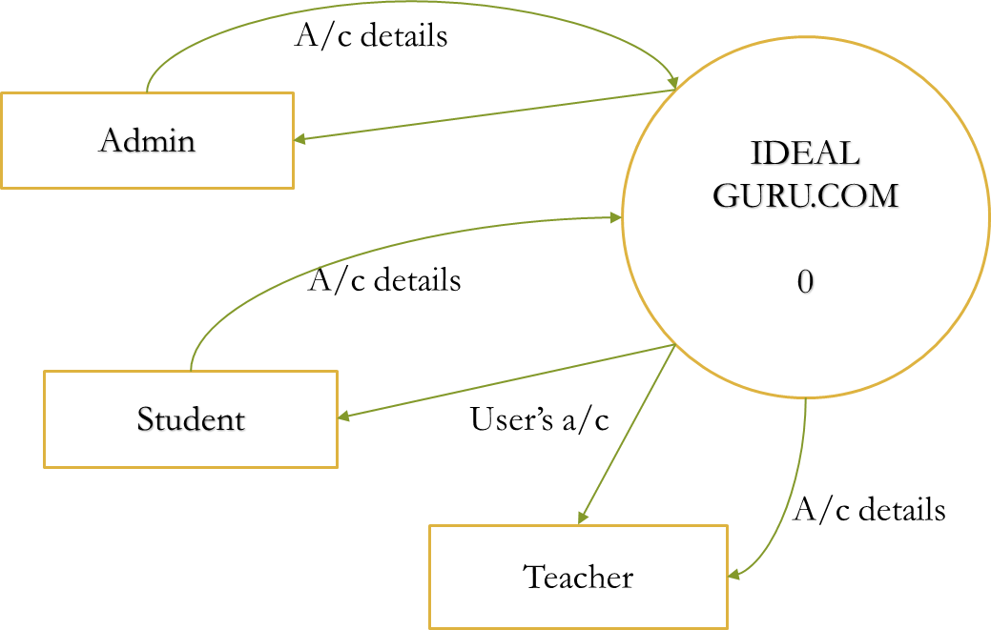

- Level 1 DFD

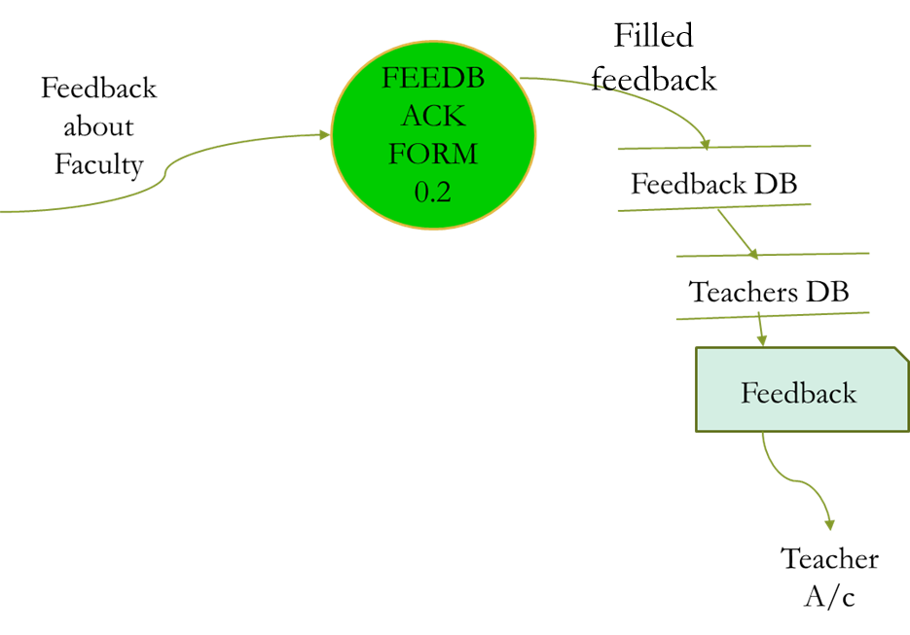

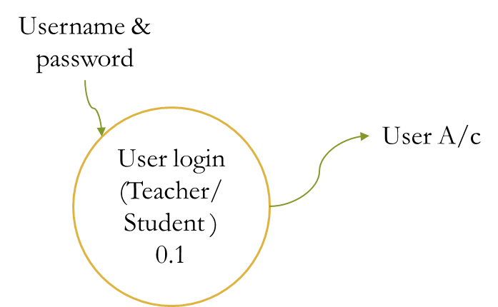

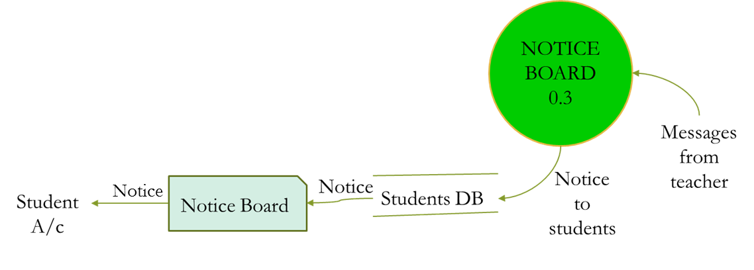

- Level 2 DFD
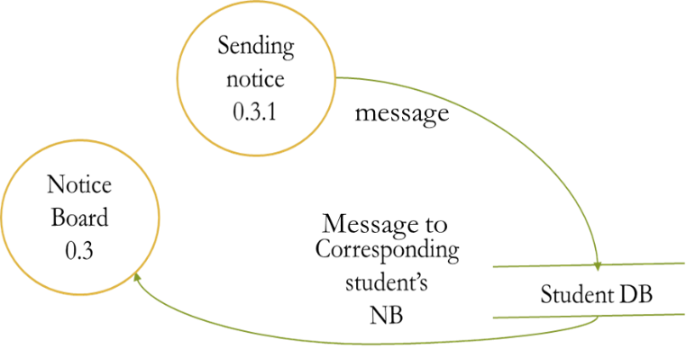
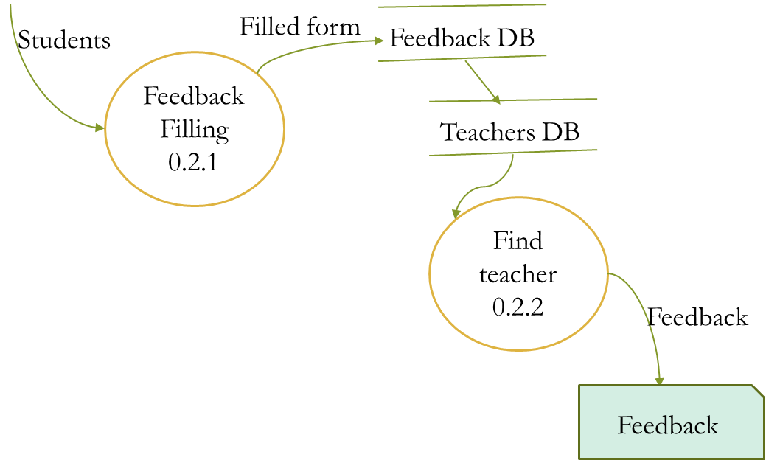
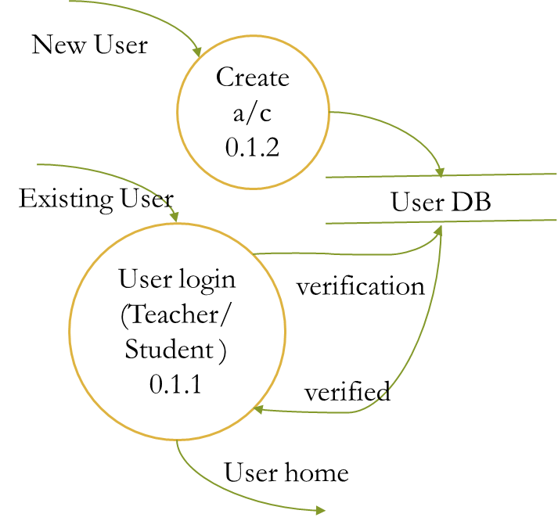
4.4 FORM DESIGN

- Home

- Login (Faculty)
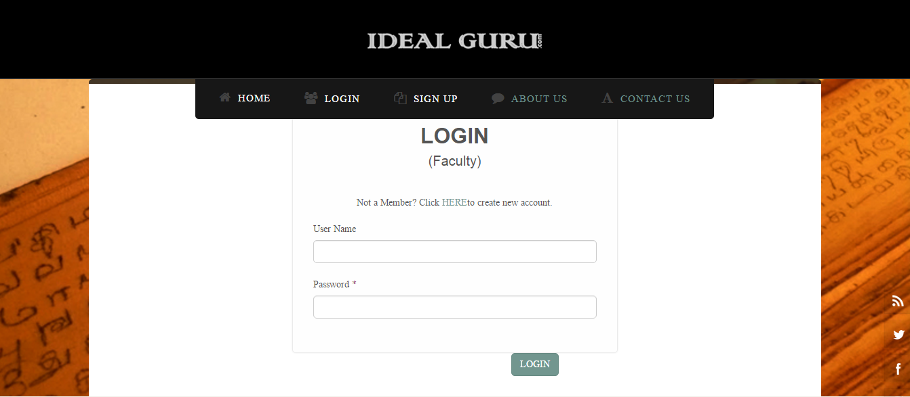

- Login (Student)

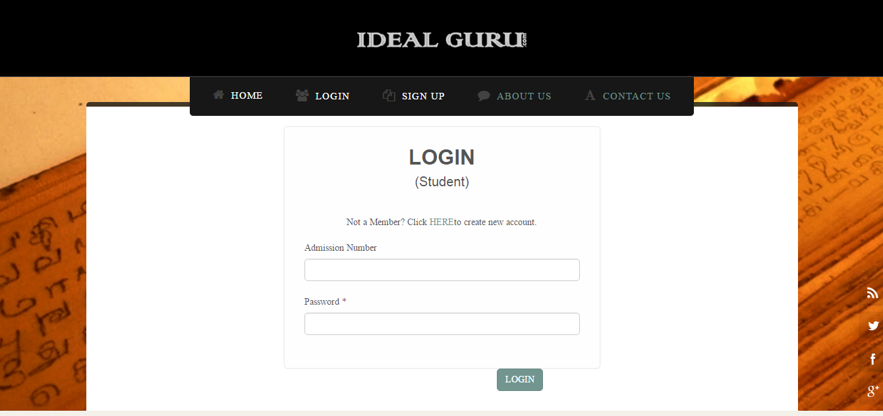
- Signup
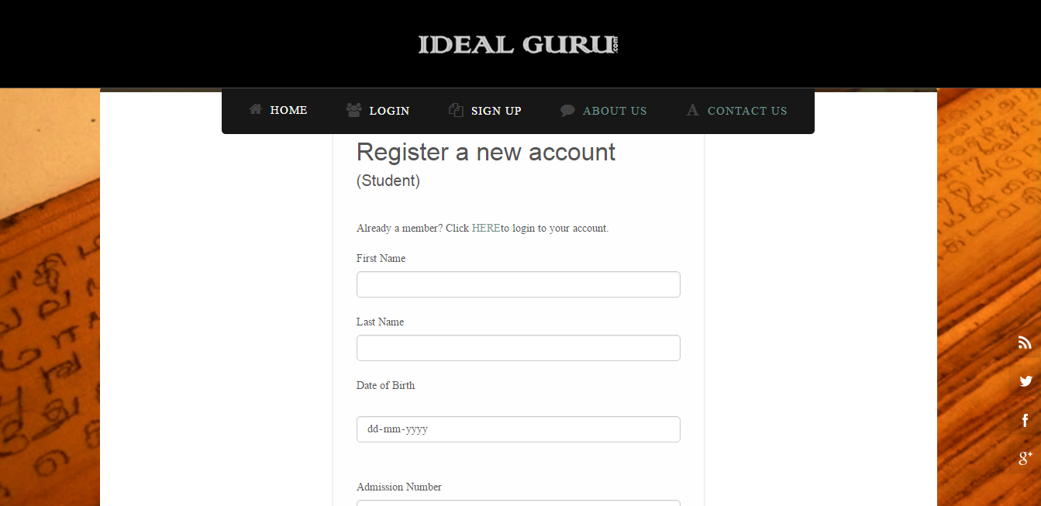

- About
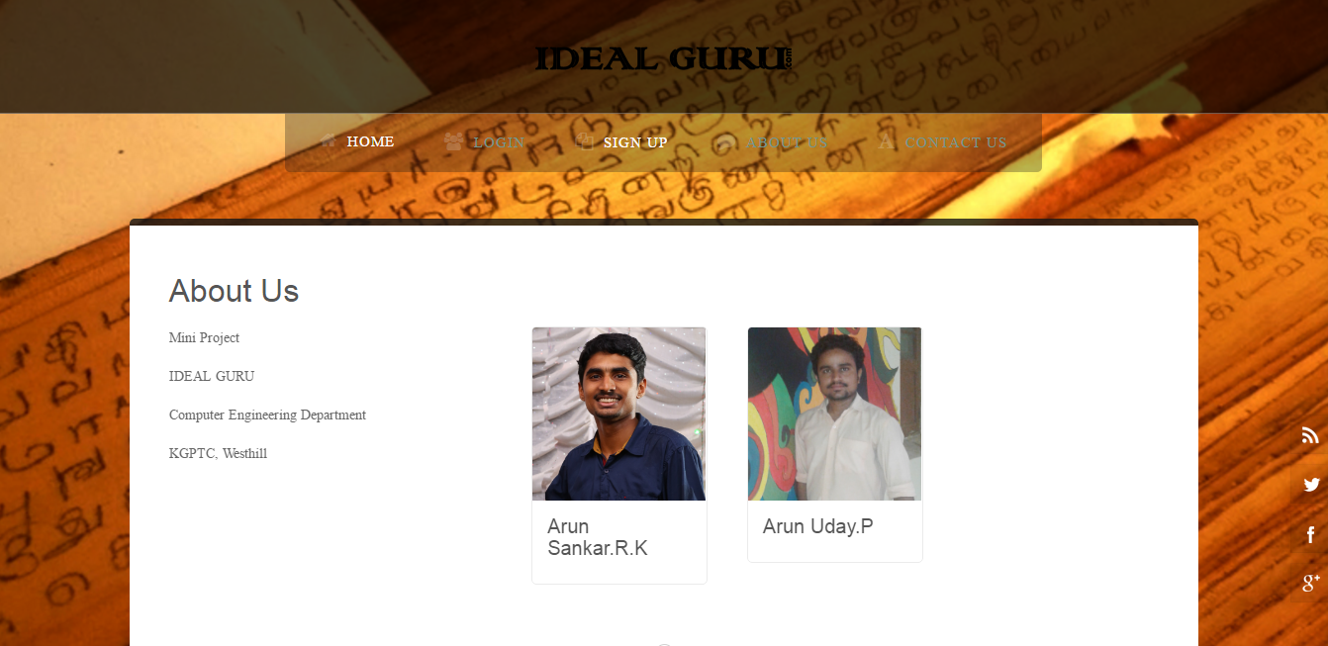
- Contact us
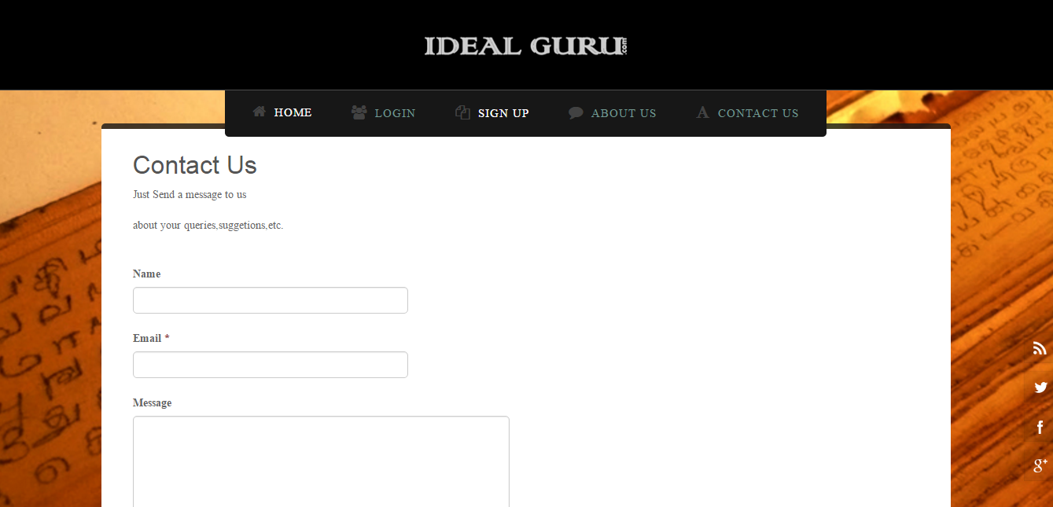

- User Home
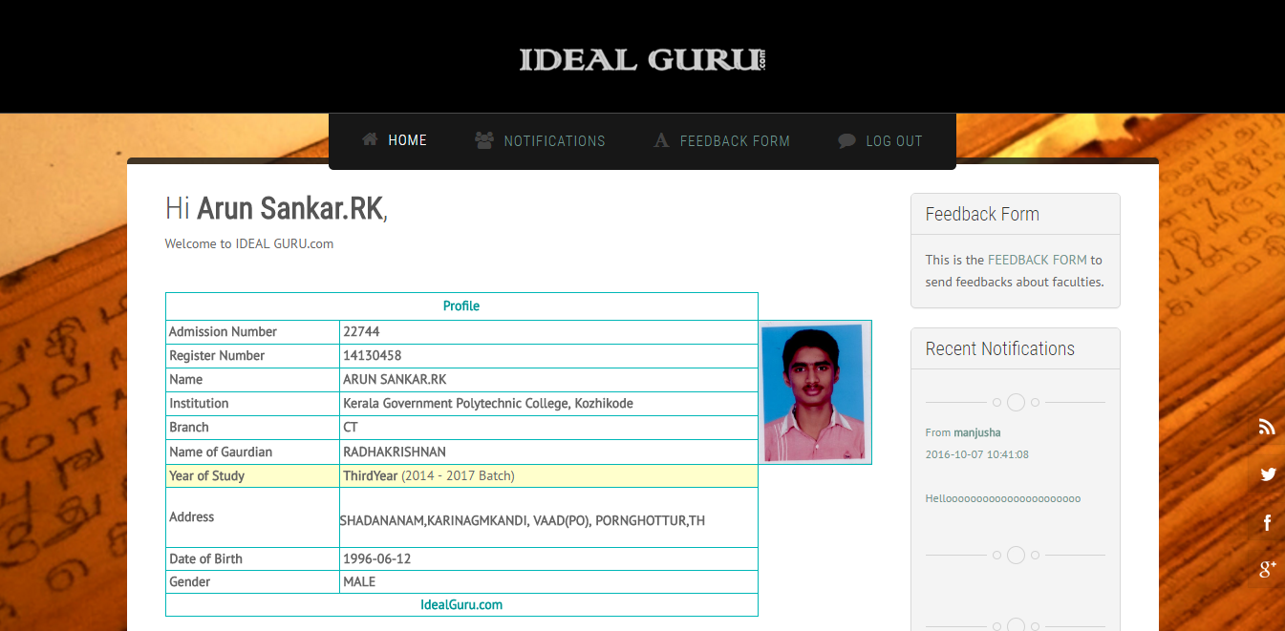

- Feedback form
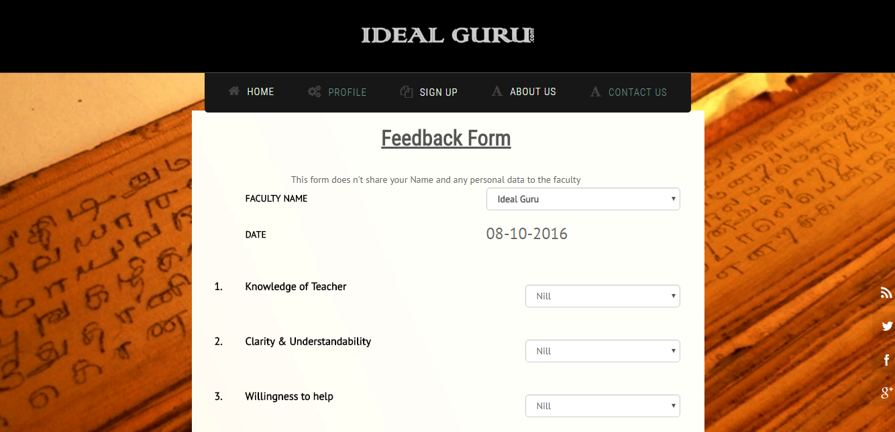
- Notification
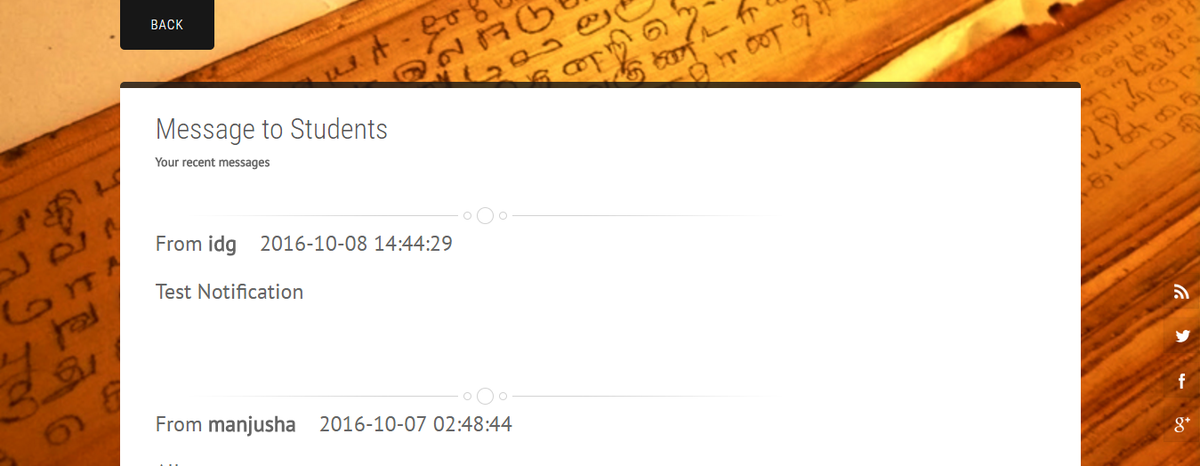

5. CONCLUSION

Using this project we can maintain a good relation between students and teachers. They can develop their attitude through this.
This project is a web application which runs in a web server so that users of any platforms can access the system to utilise its resources and features.
We have given centralised control of the system to the administrator so that he can act as a moderator between students and teachers of the system and they can have total abstraction of the internal details. The User interface is made user friendly.
We have try to fulfil all the requirements that are specified in the project abstract and all the necessary steps are takes for further development.

FUTURE SCOPE

In future this system can be implemented in all educational institutions to create a good interaction between students and teachers without hesitation. It helps teachers to receive direct feedback from students. This can be implemented by adding more security features to the system we had developed. Multiple features can be included along with the system in future more than this.
It can be implemented even in business firms and government institutions with more advanced features and according to their working manner to make a good relationship with users and concerned authority. We can successfully use this system in several surveys related to people. It helps to receive quick and true output in short duration.

